**Power BI Assignment 2**

1. Explain the advantages of Natural Queries in PowerBi with an example?

Answer:

## Natural Language Queries (NLQ) in Power BI allow users to interact with their data using everyday language rather than writing complex queries or using technical terms. NLQ enables users to ask questions in a more natural and intuitive way, making data exploration and analysis more accessible to a broader audience. Here are some advantages of using Natural Language Queries in Power BI, along with an example:

## Advantages of Natural Language Queries in Power BI:

## User-Friendly Interaction: NLQ allows users to ask questions in plain language, making it easier for non-technical users to access and analyze data without needing to know the specifics of database querying languages.

## Reduced Learning Curve: NLQ eliminates the need to learn SQL or other query languages, reducing the learning curve for new users and enabling them to quickly start interacting with the data.

## Increased Speed: Users can quickly obtain insights by asking questions directly, without having to create complex queries or rely on predefined reports or dashboards.

## Accessibility: NLQ makes data analysis more accessible to a wider range of individuals within an organization, including business analysts, managers, and decision-makers who may not have a technical background.

## Natural Flow of Thought: Users can express their questions in a way that follows their natural thought process, enabling more efficient and effective exploration of data.

## Iterative Exploration: Users can easily refine their questions or pivot their analysis based on initial results, creating a more iterative and dynamic data exploration process.

## Quick Answers to Ad-Hoc Questions: NLQ allows users to ask ad-hoc questions on the fly, enabling them to get answers to specific queries without the need for predefined reports.

## Example of Natural Language Query in Power BI:

## Let's consider an example of a sales dashboard in Power BI. A user, Sarah, is a sales manager who wants to understand the sales performance of different products for the past quarter. Instead of using SQL or a predefined report, Sarah can use Natural Language Queries to interact with the data:

Traditional Query Approach (SQL):

## SELECT ProductName, SUM(SalesAmount) AS TotalSales

## FROM Sales WHERE Date >= '2023-04-01' AND Date <= '2023-06-30'

## GROUP BY ProductName

## ORDER BY TotalSales DESC;

## 

## Natural Language Query Approach: "Show me the total sales for each product from April to June 2023."

## In this example, Sarah used a natural language query to directly ask for the information she needs. Power BI processes the question, translates it into a relevant query, and displays a visualization showing the total sales for each product during the specified time frame.

## This illustrates how natural language queries simplify the interaction between users and data. Sarah doesn't need to know SQL or navigate complex interfaces; she can simply express her query naturally and receive meaningful insights in return.

## 

In the dashboard, there is a search bar that says **Ask a question about your data.**

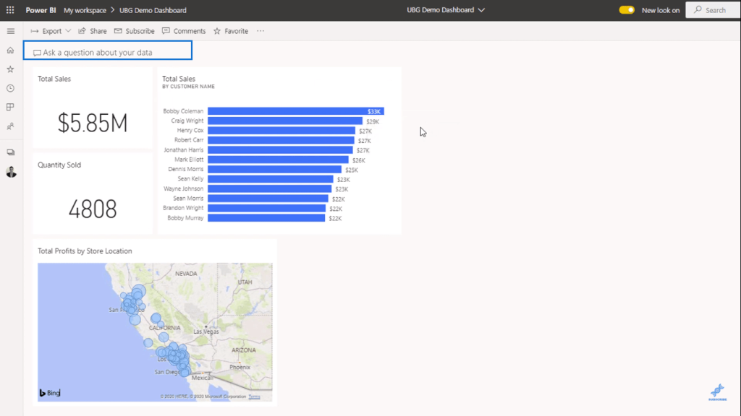

You can find insights that might not exist in your report but exist in your model based on the measures you’ve already created.

It’s important to build your model well for instances like these. The Natural Language Query works best with a solid and detailed model.

First, I’ll activate the **New Q&A experience**.

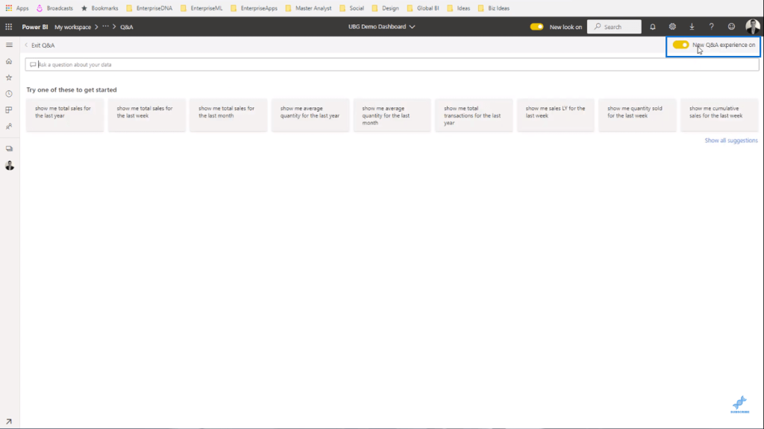

Because this is constantly updated, it might look different from yours.

It will give you some suggestions to start with.

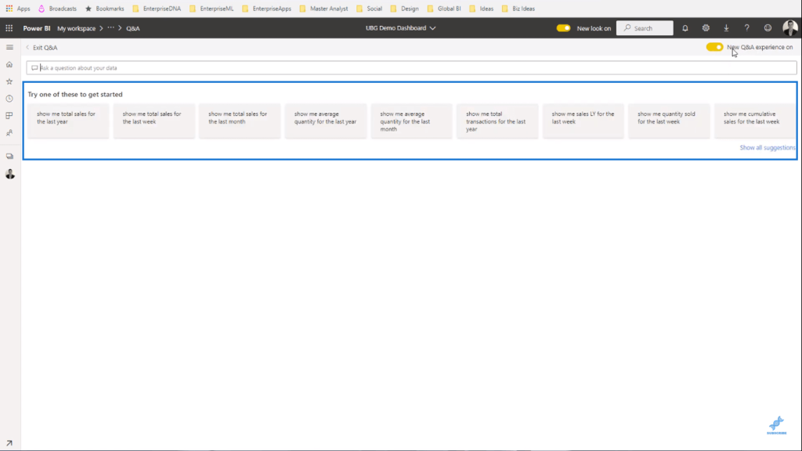

## Using Naming Conventions In Queries

Naming conventions are crucial because they label your information as a basis.

I’ll type **show total profits by product name** in the search bar and the results will appear automatically.

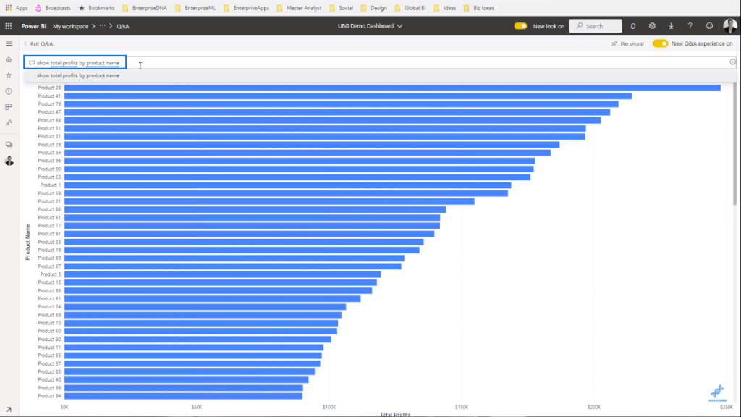

And it’s retrieving this information based on the measure and column name that I typed in. Q&A uses them to search for the information I asked for.

Now I could go even further and type **in year 2019**.

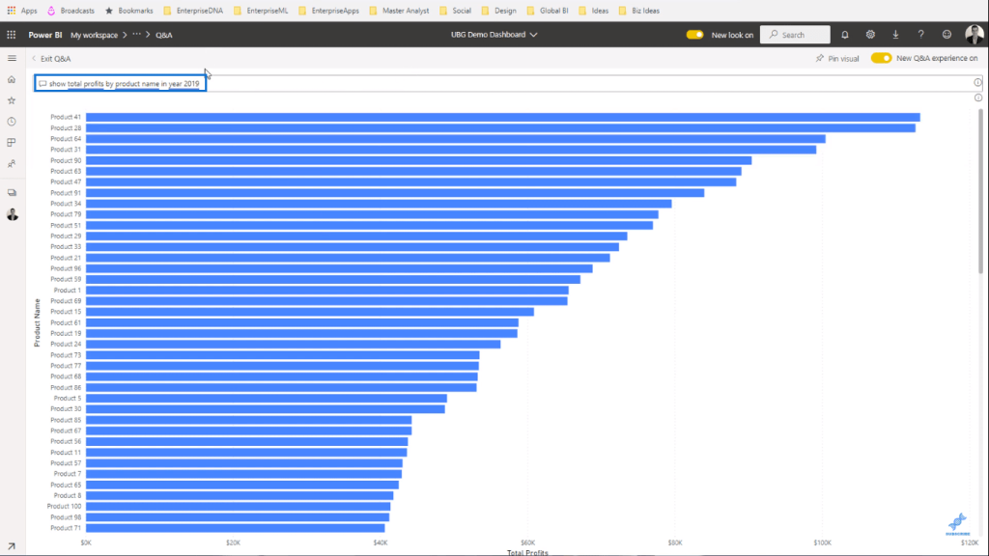

It can also give a breakdown by year as a stacked bar chart.

I’ll replace **2019** and type **as stacked bar chart** and it will show the data like this.

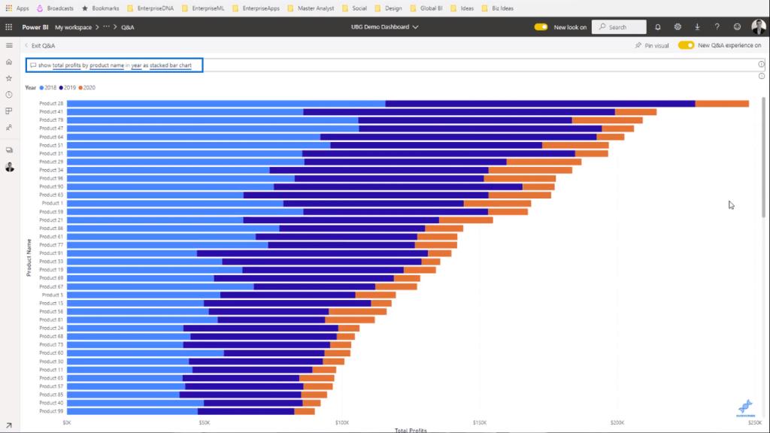

You can also pin the visual to your dashboard.

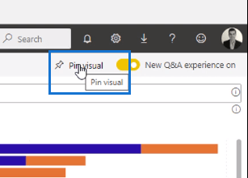

The only downside to this is that you’re unable to adjust the colors of your visuals. But in terms of functionality, it’s very effective.

1. Explain Web Front End(WFE) cluster from Power BI Service Architecture?

Answer: The WFE cluster uses Azure AD to authenticate clients, and provide tokens for subsequent client connections to the Power BI service. Power BI uses the Azure Traffic Manager (Traffic Manager) to direct user traffic to the nearest datacenter. Traffic Manager directs requests using the DNS record of the client attempting to connect, authenticate, and to download static content and files. Power BI uses the Azure Content Delivery Network (CDN) to efficiently distribute the necessary static content and files to users based on geographical locale.

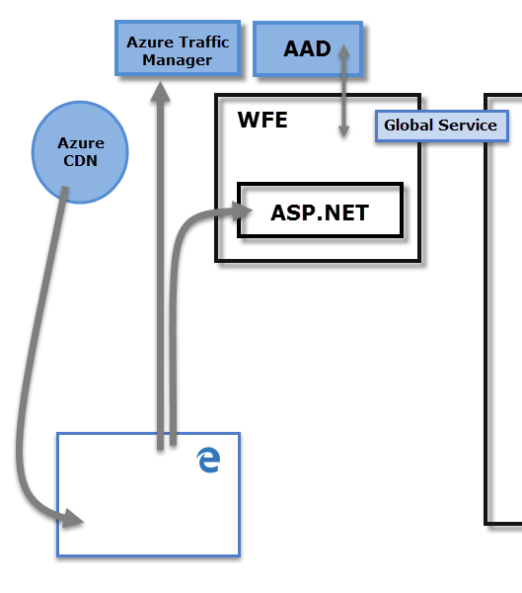

1. Explain Back End cluster from Power BI Service Architecture?

Answer: The Back-End cluster determines how authenticated clients interact with the Power BI service. The Back-End cluster manages visualizations, user dashboards, datasets, reports, data storage, data connections, data refresh, and other aspects of interacting with the Power BI service. The Gateway Role acts as a gateway between user requests and the Power BI service. Users don't interact directly with any roles other than the Gateway Role. Azure API Management eventually handles the Gateway Role.

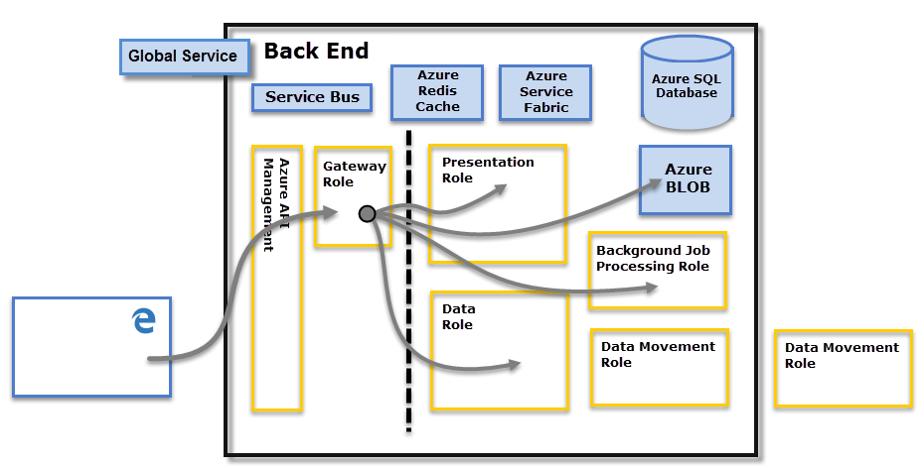

1. What ASP.NET component does in Power BI Service Architecture?

### 

### Answer :

### Components of Power BI Architecture

Let us learn about the components of Power BI architecture in detail.

#### 1. Data Sources

An important component of Power BI is its vast range of data sources. You can import data from files in your system, cloud-based online data sources or connect directly to live connections. If you import from data on-premise or online services there is a limit of 1 GB. Some commonly used data sources in Power BI are:

* Excel
* Text/CSV
* XML
* JSON
* Oracle Database
* IBM DB2 Database
* MySQL Database
* PostgreSQL Database
* Sybase Database
* Teradata Database
* SAP HANA Database
* SAP Business Warehouse server
* Amazon Redshift
* Impala
* Google BigQuery (Beta)
* Azure SQL Database
* Salesforce Reports
* Google Analytics
* Facebook
* GitHub

*You must learn about* [*Power BI Data Sources*](https://data-flair.training/blogs/data-sources-for-power-bi/) *thoroughly*

#### 2. Power BI Desktop

Power BI Desktop is a client-side tool known as a companion development and authoring tool.

This desktop-based software is loaded with tools and functionalities to *connect to data sources, transform data, data modeling and creating reports.*

You can download and install Power BI Desktop in your system for free. Using Power BI Desktop features, one can do *data* *cleansing, create business metrics and data models, define the relationship between data, define hierarchies, create visuals and publish reports.*

#### 3. Power BI Service

Power BI Service is a web-based platform from where you can *share reports made on Power BI Desktop, collaborate with other users, and create dashboards.*

It is available in three versions:

* Free version
* Pro version
* Premium version

Power BI Service is also known as, “Power BI.com”, “Power BI Workspace”, “Power BI Site” and “Power BI Web Portal”. This component also offers advanced features like *natural language Q&A* and *alerts*.

#### 4. Power BI Report Server

The Power BI Report Server is similar to the Power BI Service. The only difference between these two is that Power BI Report Server is an on-premise platform. It is used by organizations who do not want to publish their reports on the cloud and are concerned about the security of their data.

Power BI Report Server enables you to create dashboards and share your reports with other users following proper security protocols. To use this service, you need to have a Power BI Premium license.

5. Power BI Gateway

This component is used to connect and access on-premise data in secured networks. Power BI Gateways are generally used in organizations where data is kept in security and watch. Gateways help to extract out such data through secure channels to Power BI platforms for analysis and reporting.

#### 6. Power BI Mobile

Power BI Mobile is a native Power BI application that runs on iOS, Android, and Windows mobile devices. For viewing reports and dashboards, these applications are used.

#### 7. Power BI Embedded

Power BI Embedded offers APIs that are used to embed visuals into custom applications.

### Working of Power BI Architecture

Power BI Desktop is a companion development, authoring, and publishing tool. You can import data from data sources to Power BI Desktop and use it to create reports and then publish them on a Power BI Service or Power BI Report Server.

You can also publish Excel workbooks directly using Power BI Publisher for Excel to the Power BI Report Server. The SQL Server Data tools and Report Publisher help in *creating datasets, KPIs, mobile reports, paginated reports,* etc. The reports from all kinds of reports are published to the Power BI Report Server from where they are distributed to the end-users.

On-Cloud

An important component in Power BI architecture is the Power BI Gateway. The Power BI Gateway acts as a secure channel to transport data from on-premise data sources to on-cloud apps or sites.

On the cloud side of the architecture, resides a lot of components. Like a complete Power BI suite having *dataflows, datasets, dashboards, reports, Power BI Embedded, Power BI Premium,* etc. You can embed your reports and dashboards into *Teams, SharePoint, custom applications,* etc. There are on-cloud data sources as well that connects to Power BI tools via direct connections.

At last, there is a layer of authenticated users who share the published reports and dashboard and collaborate with one another to make educated decisions based on the insights. There are different kinds of users who consume Power BI reports and dashboards and connect through *web browsers, Excel, third-party tools, and mobile devices* (iOS, Windows, Android apps).

### Power BI Service

As we have learned in the earlier sections, all the reports that you create in Power BI Desktop are published on a cloud platform known as Power BI Service.

Users can access the reports and dashboards from Power BI Service using client platforms like websites, mobile devices, etc. This means that every client who wants to access content created on Power BI needs to interact with Power BI Service. And so, we must take a look under the hood and learn how Power BI Service works.

Power BI Service’s architecture consists of two parts:

* A front end
* A back end

Front End cluster

The front end also called the web front-end cluster acts as an intermediary between clients and the back end. The front end services are used for establishing an initial connection and authenticating clients using Azure Active Directory. The Azure Active Directory stores user identities.

Along with this, Azure Traffic Manager is used to direct user requests to the nearest data center after authentication. Once a client/user is authenticated, the Azure Content Delivery Network (CDN) distributes static Power BI content/files to users.

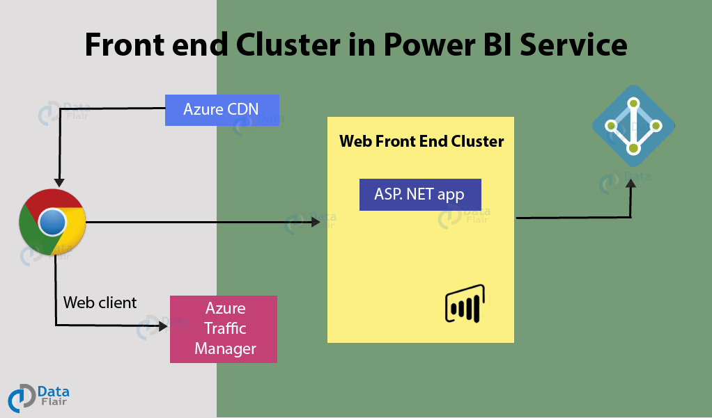

Back End Cluster

The Power BI services at the back end take care of *visualizations, datasets, storage, reports, data connections, data refreshing, and other interactions* with Power BI. At the back-end, a web client has only two direct points of interaction, Azure API Management, and Gateway Role. These two components are responsible for *load balancing, authentication, authorization, routing,* etc.

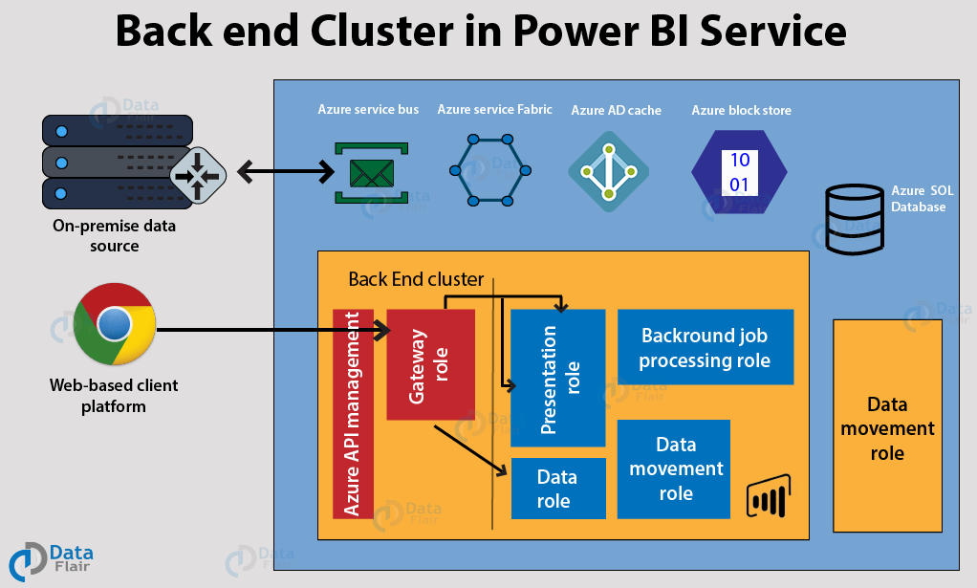

### Working of Power BI Service

* Power BI stores its data in two main repositories; Azure block storage and Azure SQL database. Azure block storage stores the datasets uploaded by users and all the metadata and system-related data is stored in the Azure SQL database.
* After Azure API Management authenticates a user request, it is sent to the Gateway Role. The Gateway Role processes the requests and directs them to suitable components like *Presentation Role, Background Job Processing Role, Data Role, and Data Movement Role.*
* For instance, the Presentation Role handles all the visualization related queries like for dashboards and reports.
* For all the data related queries, the request is sent by the Gateway Role to the Data Role or Data Movement Role.
* Power BI Service back end uses Azure Service Bus to connect on-premise datasources with the cloud. Azure Service Bus receives all the requests to fetch data from the on-premise data source. Then it processes the request and executes the query on the on-premise data source to retrieve data from it to the cloud service.
* The Azure Service Fabric manages all the microservices and components associated with running Power BI.
* Azure AD Cache helps in real-time reporting using the data stored i

1. Compare Microsoft Excel and PowerBi Desktop on the following features:

Data import

Data transformation

Modeling

Reporting

Server Deployment

Convert Models

Cost

Answer:

**1. Data Import:**

* Microsoft Excel: Excel allows users to import data from various sources such as databases, text files, web data, and more. However, the process might involve manual steps, and larger datasets can lead to performance issues.
* Power BI Desktop: Power BI Desktop provides more streamlined data import capabilities. It supports a wide range of data connectors and simplifies the process of connecting to and importing data from multiple sources.

**2. Data Transformation:**

* Microsoft Excel: Excel offers basic data transformation features using functions, PivotTables, and Power Query. Complex transformations might require writing formulas and custom scripts.
* Power BI Desktop: Power BI Desktop includes Power Query, a powerful ETL (Extract, Transform, Load) tool that enables users to transform, clean, and shape data using a user-friendly interface.

**3. Modeling:**

* Microsoft Excel: Excel supports basic data modeling using PivotTables, PivotCharts, and formulas. It lacks more advanced modeling capabilities.
* Power BI Desktop: Power BI Desktop provides robust data modeling features, including the ability to create relationships between tables, define calculated columns and measures, and establish hierarchies.

**4. Reporting:**

* Microsoft Excel: Excel allows users to create basic reports using tables, charts, and graphs. However, complex visualization might be challenging, and maintaining report consistency can be difficult.
* Power BI Desktop: Power BI Desktop is optimized for creating rich and interactive visual reports. It offers a wide range of customizable visualizations, themes, and interactive features.

**5. Server Deployment:**

* Microsoft Excel: Excel files are typically stored on local devices or shared through email and file-sharing platforms. Collaboration can be limited.
* Power BI Desktop: Power BI reports can be published to the Power BI service, allowing for centralized storage, sharing, collaboration, and real-time data refresh.

**6. Convert Models:**

* Microsoft Excel: Excel models can be complex to convert into sharable and interactive reports, and data might need to be restructured for optimal reporting.
* Power BI Desktop: Power BI Desktop models are designed with interactive reporting in mind, making it easier to convert data models into visually appealing reports.

**7. Cost:**

* Microsoft Excel: Excel is often included in Microsoft Office packages. More advanced features might require a higher-tier Office subscription.
* Power BI Desktop: Power BI Desktop is a free application. However, sharing and collaborating through the Power BI service might require licenses based on user needs.

1. List 20 data sources supported by Power Bi desktop.

Answer:

**Power BI Desktop** supports a wide range of data sources that you can connect to and import data from. Here are 20 data sources supported by Power BI Desktop:

1. Excel Workbooks (local or cloud-based)
2. SQL Server Database
3. Azure SQL Database
4. Oracle Database
5. MySQL Database
6. PostgreSQL Database
7. Microsoft Access Database
8. SharePoint Lists and Libraries
9. Web Data (HTML, XML, JSON)
10. Web Services (REST APIs)
11. CSV Files
12. Text Files (TXT)
13. Folder (for loading multiple files from a folder)
14. SharePoint Folder
15. Dynamics 365
16. Google Analytics
17. Salesforce
18. OData Feeds
19. Hadoop File (HDFS)
20. SAP HANA Database

These are just a few examples of the many data sources that Power BI Desktop supports. The tool's extensive connectivity options allow users to import and transform data from a diverse range of sources for creating insightful reports and dashboards.